Dashboard Design
Team ID | MCA
Project Name | Smartphone Usage Digital Addiction & Well-Being Analytics
Maximum Marks | 5 Marks
Creating an effective dashboard involves thoughtful design to ensure that the presented information is clear, relevant, and easily understandable for the intended audience. Here are some key principles and best practices for dashboard design:
Activity 1: Interactive and visually appealing dashboards
Creating interactive and visually appealing dashboards involves a combination of thoughtful design, effective use of visual elements, and the incorporation of interactive features. Here are some tips to help you design dashboards that are both visually appealing and engaging for users, so take care of below points:
- Clear and Intuitive Layout
- Use Appropriate Visualizations
- Colour and Theming
- Interactive Filters and Slicers
- Drill-Down Capabilities
- Responsive Design
- Custom Visuals and Icons
- Use of Infographics
- 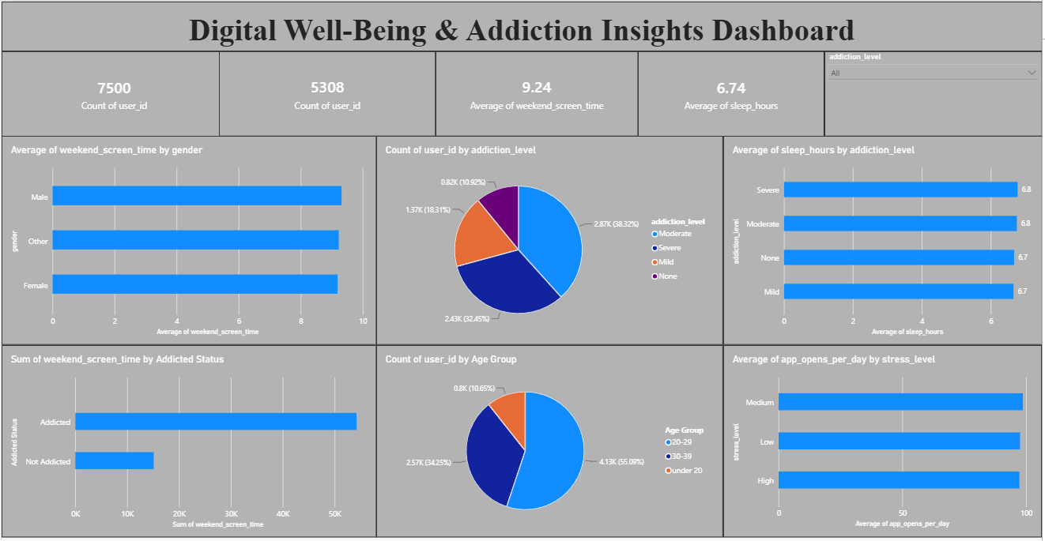
Major Outcomes and Insights from the Dashboard
Note: Highlight the major outcomes in form of bullet points as per the dashboard details:
- Total Surveyed Users: The dashboard tracks data across a base population of 7,500 total user IDs, providing a highly comprehensive sample size for behavioral insights.
- Active Study Cohort: A total subset of 5,308 user IDs were actively analyzed under specific category metrics to isolate critical screen-time behavioral variables.
- High Weekend Screen-Time: The average weekend screen time stands at a significant 9.24 hours, highlighting massive device engagement during leisure days.
- Suboptimal Sleep Levels: The overall average sleep duration is recorded at 6.74 hours, falling short of standard health recommendations and showcasing a potential impact from digital addiction.
- Addiction Level Distribution: The user base is predominantly categorized under 'Moderate' addiction (38.32% or 2.87K users) and 'Severe' addiction (32.45% or 2.43K users), with 'Mild' at 18.31% and only 10.92% showing 'None'.
- Gender Screen-Time Parity: Average weekend screen time remains nearly identical across genders, showing approximately 9 hours for Male, Female, and Other gender identities.
- Sleep Deprivation Correlation: Users with 'Severe' and 'Moderate' addiction levels exhibit standard sleep constraints averaging 6.8 hours, indicating a distinct baseline relationship between high digital dependency and sleep tracking.
- Addicted Population Volume: The vast majority of cumulative screen hours belongs to the 'Addicted' status group (exceeding 50K hours total) compared to the 'Not Addicted' group (approx. 15K hours).
- Age Demographics: The young adult demographic is highly prominent, with the 20–29 age group constituting the clear majority at 55.09% (4.13K users), followed by 30–39 years at 34.25% (2.57K users), and under 20 at 10.65% (0.8K users).
- App Open Saturation: Daily app opening counts remain consistently elevated at an average approaching nearly 100 times per day across Medium, Low, and High stress levels uniformly.

